RTX 5070 MARKET RESEARCH REPORT
Professional GPU Comparison & Buying Guide — 2026
Expanded version using the original product URLs and updated listing information.

Executive Summary
This updated report expands the previous RTX 5070 comparison instead of fully rewriting it. The same eight product entries are kept, but each card now includes more market detail, verified listing highlights, price/rating notes, strengths, weaknesses, ideal buyer type, and clickable Amazon product links. Most RTX 5070 cards deliver similar real-world FPS because they use the same GPU class, so the real buying differences are cooling quality, noise level, physical size, aesthetics, warranty confidence, and price.
Important validation note: The originally pasted ASUS Dual link appears to show an ASUS Dual RTX 5060 listing, not a verified RTX 5070 listing. It is included below because it was part of the working comparison, but it is marked clearly as a link mismatch.

Expanded Market Comparison Table
GPU Model | Tier | Price | Rating | Memory | Key Listing Specs | Market Position
ASUS Prime RTX 5070 OC | Premium / Balanced | $639.00 | 4.7/5 (533 reviews) | 12GB GDDR7 | Approx. 2542 MHz listing clock; HDMI + DisplayPort 2.1-class outputs; Axial-tech triple-fan, 2.5-slot | Best balanced option: quiet, reliable, SFF-ready, and not as expensive as the highest-end cards.
Gigabyte RTX 5070 Windforce OC | Value / Mainstream | $635.99 | 4.5/5 (623 reviews) | 12GB GDDR7, 192-bit | Approx. 2542–2600 MHz listing clock; 3 x DisplayPort 2.1a, 1 x HDMI 2.1b; WINDFORCE triple-fan cooling | Best value pick: triple-fan cooling, strong specs, and one of the more reasonable prices.
PNY RTX 5070 OC Epic-X RGB | Mid-range / RGB | $636.13 | 4.6/5 (555 reviews) | 12GB GDDR7, 192-bit | Boost speed 2685 MHz; HDMI + DisplayPort 2.1-class outputs; Triple-fan, 2.4-slot, SFF-ready | Good RGB mid-range choice with strong boost clock and a compact 2.4-slot design.
MSI RTX 5070 Gaming Trio | Enthusiast / Premium Cooling | $669.99 | 4.7/5 (191 reviews) | 12GB GDDR7, 192-bit | Extreme Performance: 2625 MHz; 3 x DisplayPort 2.1a, 1 x HDMI 2.1b; Large triple-fan Gaming Trio cooler | Best premium cooler pick: quiet, high quality, and stronger sustained boost under long gaming sessions.
MSI RTX 5070 Ventus | Budget / Mainstream MSI | $639.99 | 4.5/5 (150 reviews) | 12GB GDDR7, 192-bit | Extreme Performance: 2557 MHz; 3 x DisplayPort 2.1a, 1 x HDMI 2.1b; Ventus 3X triple-fan cooler | Affordable MSI option with triple-fan cooling, but less premium than Gaming Trio.
Gigabyte RTX 5070 Aero OC | Premium / White Build | $689.99 | 4.7/5 (348 reviews) | 12GB GDDR7, 192-bit | Approx. 2625 MHz listing clock; 3 x DisplayPort 2.1a, 1 x HDMI 2.1b; WINDFORCE cooling system | Best aesthetic choice: white design, premium look, and strong cooling for display builds.
ASUS Dual RTX 5070 / Link Validation Note | Compact / Listing Mismatch | $354.39 shown for linked page | 4.6/5 (384 reviews) | Linked page shows RTX 5060 8GB GDDR7 | Not verified as RTX 5070 from provided link; HDMI 2.1b + DisplayPort 2.1b on linked RTX 5060 listing; Dual Axial-tech fan design | Important: the pasted ASUS Dual URL appears to open an RTX 5060 listing, not an RTX 5070.
MSI RTX 5070 Shadow | Budget / Compact | $629.99 for Shadow 3X related listing; 2X page requires sign-in for live price | Not clearly shown on provided 2X link | 12GB listing memory; note page text shows GDDR6X, likely listing inconsistency | Approx. 2.54 GHz / 2557 MHz related listing; DisplayPort + HDMI; 2X or 3X depending on exact Shadow listing | Budget MSI card; useful if cheap, but listing details are less clean than the others.

ASUS Prime RTX 5070 OC
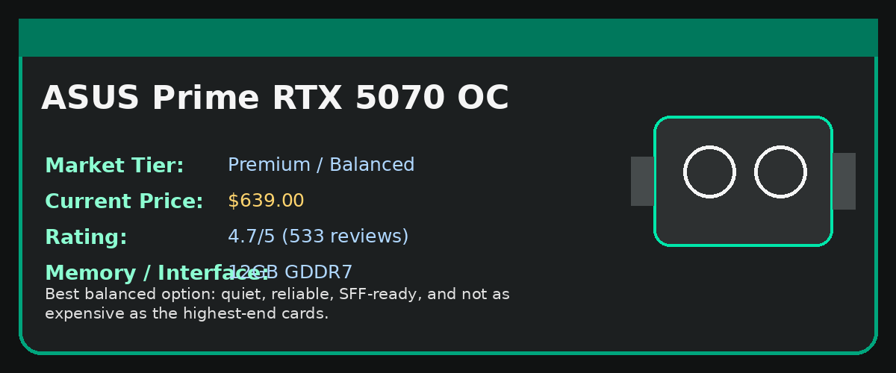
Market Tier | Premium / Balanced
Current / Listed Price | $639.00
Rating Score | 4.7/5 (533 reviews)
Memory / Bus | 12GB GDDR7
Clock / Outputs / Cooling | Approx. 2542 MHz listing clock; HDMI + DisplayPort 2.1-class outputs; Axial-tech triple-fan, 2.5-slot
Best Buyer Type | Users who want the safest overall RTX 5070 purchase with good thermals, quiet fans, and reliable build quality.

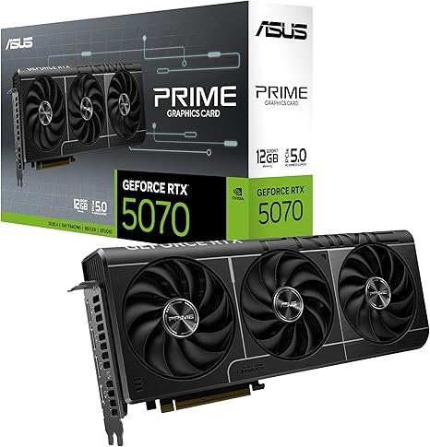

Expanded Market Explanation
The ASUS Prime RTX 5070 OC is the strongest balanced pick in this group. The Amazon listing highlights PCIe 5.0 support, 12GB GDDR7 memory, HDMI/DisplayPort 2.1-class outputs, a 2.5-slot design, Axial-tech fans, Dual BIOS, and a 3-year warranty. In market positioning, this card sits between entry-level RTX 5070 models and large enthusiast cards. It is not the absolute fastest cooler, but it offers a strong mix of quiet operation, reliable ASUS build quality, and manageable size.

Strengths
- Strong cooling design without becoming overly large.
- Dual BIOS gives a useful choice between performance and quieter operation.
- Good choice for 1440p gaming, creative work, and long-term everyday use.
- High Amazon rating and review count compared with many other RTX 5070 listings.

Weaknesses / Buying Cautions
- Not the cheapest RTX 5070 option.
- Minimal styling compared with RGB-heavy cards.
- Performance difference over cheaper models is usually small in real FPS.
Amazon Product Link: Open Product Page

Gigabyte RTX 5070 Windforce OC
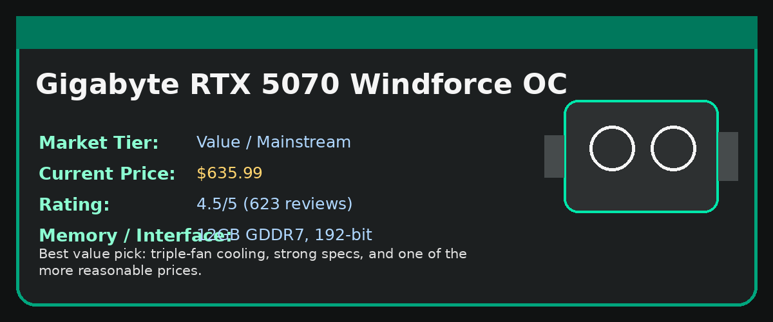
Market Tier | Value / Mainstream
Current / Listed Price | $635.99
Rating Score | 4.5/5 (623 reviews)
Memory / Bus | 12GB GDDR7, 192-bit
Clock / Outputs / Cooling | Approx. 2542–2600 MHz listing clock; 3 x DisplayPort 2.1a, 1 x HDMI 2.1b; WINDFORCE triple-fan cooling
Best Buyer Type | Gamers who want RTX 5070 performance while spending less than premium ASUS, MSI, or white-theme models.

Expanded Market Explanation
The Gigabyte RTX 5070 Windforce OC is the strongest value-focused card in the comparison. The listing shows 12GB GDDR7 memory, a 192-bit interface, PCIe 5.0, WINDFORCE cooling, and modern display outputs. Compared with premium ASUS or MSI models, it focuses more on price-to-performance than luxury design. It still has a triple-fan cooler, which makes it a better option than very basic dual-fan cards for users who care about thermals.

Strengths
- Very strong price-to-performance position.
- Triple-fan cooler at a lower price than most premium RTX 5070 models.
- Good fit for 1440p gaming builds where budget matters.
- Modern output layout with DisplayPort 2.1a and HDMI 2.1b.

Weaknesses / Buying Cautions
- Build quality and finish feel more mainstream than premium.
- May run slightly louder than higher-end coolers under load.
- Design is simple and less aesthetic-focused.
Amazon Product Link: Open Product Page

PNY RTX 5070 OC Epic-X RGB
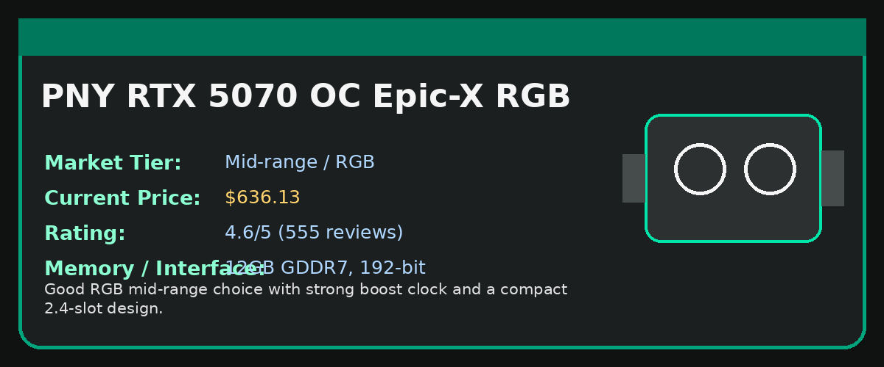
Market Tier | Mid-range / RGB
Current / Listed Price | $636.13
Rating Score | 4.6/5 (555 reviews)
Memory / Bus | 12GB GDDR7, 192-bit
Clock / Outputs / Cooling | Boost speed 2685 MHz; HDMI + DisplayPort 2.1-class outputs; Triple-fan, 2.4-slot, SFF-ready
Best Buyer Type | Users who want RGB styling, compact sizing, and strong specs without paying high premium-card prices.

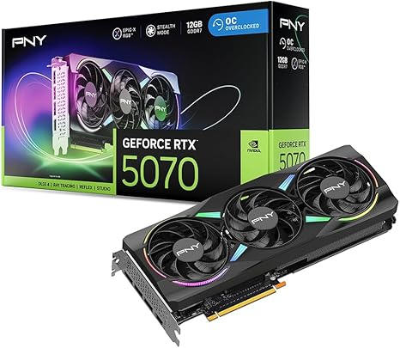

Expanded Market Explanation
The PNY Epic-X ARGB OC is a strong mid-range RTX 5070 option with a good mix of design, cooling, and price. The listing highlights 12GB GDDR7 memory, a 192-bit bus, a 2685 MHz boost speed, SFF-ready support, PCIe 5.0, HDMI/DisplayPort 2.1-class outputs, Blackwell architecture, and DLSS 4. The biggest advantage here is that it offers RGB styling and a high listed boost clock while staying near value-card pricing.

Strengths
- Highest listed boost clock among several items in this comparison.
- ARGB design gives better visual appeal than plain models.
- 2.4-slot design is easier to fit than very large enthusiast cards.
- Good rating and review count on Amazon.

Weaknesses / Buying Cautions
- PNY may have lower brand preference than ASUS/MSI for some buyers.
- Software ecosystem is less popular than ASUS Armoury Crate or MSI Center.
- Resale value may be slightly lower than ASUS/MSI cards.
Amazon Product Link: Open Product Page

MSI RTX 5070 Gaming Trio
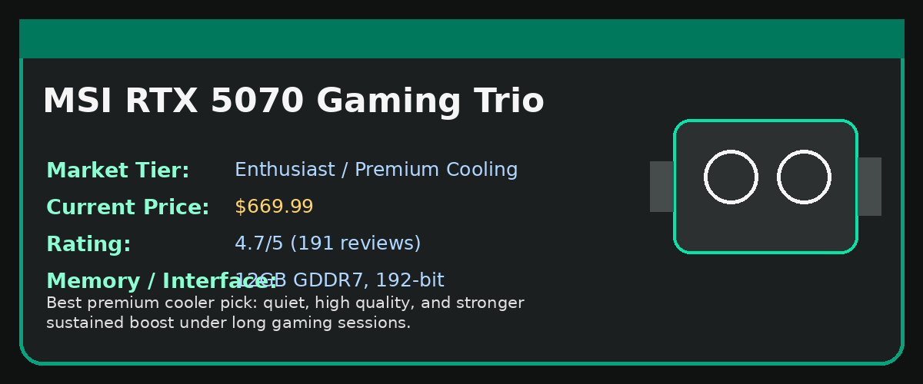
Market Tier | Enthusiast / Premium Cooling
Current / Listed Price | $669.99
Rating Score | 4.7/5 (191 reviews)
Memory / Bus | 12GB GDDR7, 192-bit
Clock / Outputs / Cooling | Extreme Performance: 2625 MHz; 3 x DisplayPort 2.1a, 1 x HDMI 2.1b; Large triple-fan Gaming Trio cooler
Best Buyer Type | Enthusiast gamers who want a quiet, cool-running RTX 5070 and are willing to pay more for a premium cooler.

Expanded Market Explanation
The MSI RTX 5070 Gaming Trio is the premium gaming pick in the list. The listing highlights 12GB GDDR7 memory, a 192-bit interface, a 2625 MHz performance clock, DisplayPort 2.1a, HDMI 2.1b, and NVIDIA Blackwell architecture. Its market advantage is not huge FPS gains; instead, it is better cooling, quieter fan behavior, and more stable boost clocks during long gaming or rendering sessions. It is a better buy when the price gap from budget cards is not too high.

Strengths
- One of the best cooling solutions among the listed RTX 5070 models.
- Quiet operation makes it attractive for premium gaming PCs.
- Good for long gaming sessions and airflow-focused cases.
- Strong brand reputation in gaming GPU coolers.

Weaknesses / Buying Cautions
- Large card size may cause case compatibility issues.
- Costs more than value models while FPS gains are usually limited.
- Not ideal for compact PC cases.
Amazon Product Link: Open Product Page

MSI RTX 5070 Ventus
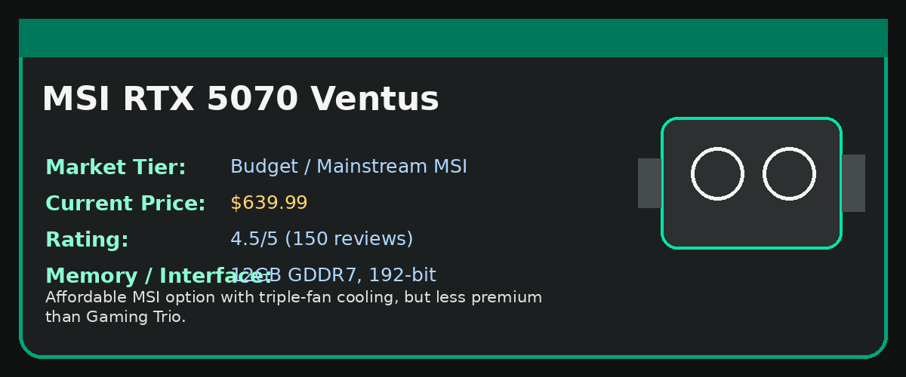
Market Tier | Budget / Mainstream MSI
Current / Listed Price | $639.99
Rating Score | 4.5/5 (150 reviews)
Memory / Bus | 12GB GDDR7, 192-bit
Clock / Outputs / Cooling | Extreme Performance: 2557 MHz; 3 x DisplayPort 2.1a, 1 x HDMI 2.1b; Ventus 3X triple-fan cooler
Best Buyer Type | Buyers who want an MSI RTX 5070 at a lower price and do not need premium RGB or top-tier cooling.

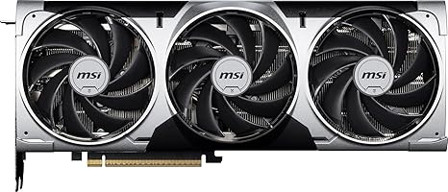

Expanded Market Explanation
The MSI RTX 5070 Ventus 3X OC is MSI’s mainstream RTX 5070 card. The listing includes 12GB GDDR7 memory, a 192-bit bus, 2557 MHz performance clock, DisplayPort 2.1a, HDMI 2.1b, and NVIDIA Blackwell architecture. Compared with the MSI Gaming Trio, the Ventus is built to be more affordable. It still has a triple-fan design, but the cooler, aesthetics, and power delivery are more basic.

Strengths
- Good entry point for users who prefer MSI branding.
- Triple-fan cooler gives it better thermal potential than small dual-fan options.
- Usually cheaper than MSI Gaming Trio.
- Clean, simple design for non-RGB builds.

Weaknesses / Buying Cautions
- Not as quiet or premium as Gaming Trio.
- Less overclocking headroom than enthusiast models.
- At similar prices, Windforce or PNY may offer better value depending on stock.
Amazon Product Link: Open Product Page

Gigabyte RTX 5070 Aero OC
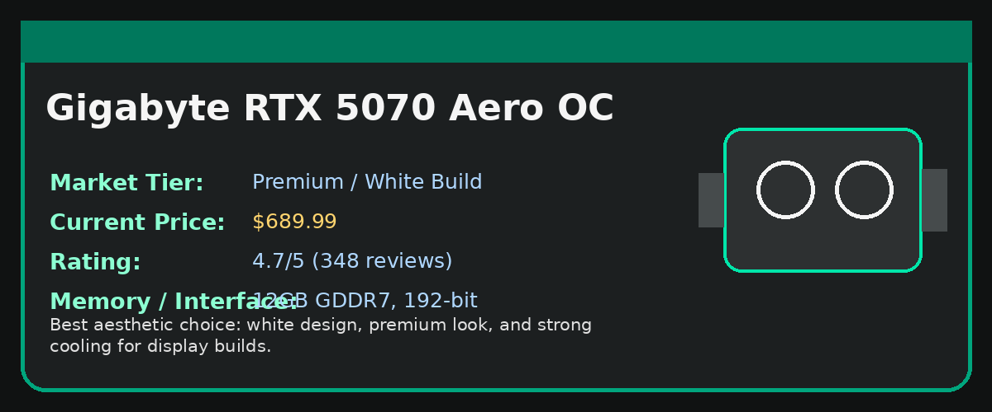
Market Tier | Premium / White Build
Current / Listed Price | $689.99
Rating Score | 4.7/5 (348 reviews)
Memory / Bus | 12GB GDDR7, 192-bit
Clock / Outputs / Cooling | Approx. 2625 MHz listing clock; 3 x DisplayPort 2.1a, 1 x HDMI 2.1b; WINDFORCE cooling system
Best Buyer Type | Users building a white-themed PC who want the GPU to match the rest of the setup.

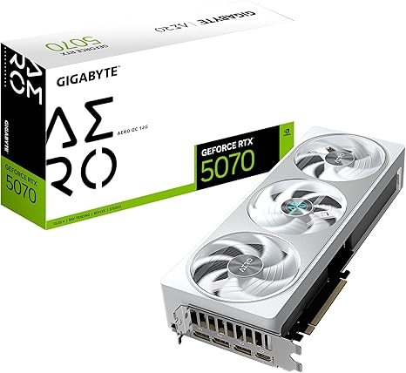

Expanded Market Explanation
The Gigabyte RTX 5070 Aero OC targets users who care about aesthetics as much as performance. The Amazon listing highlights NVIDIA Blackwell architecture, DLSS 4, 12GB GDDR7 memory, a 192-bit interface, PCIe 5.0, and the WINDFORCE cooling system. It generally costs more than the Windforce model because of its white theme and premium visual design, not because it will produce dramatically higher FPS.

Strengths
- Excellent choice for white PC builds and showpiece gaming setups.
- Strong triple-fan WINDFORCE cooling.
- Premium visual design with good market appeal.
- Good listed rating and review volume.

Weaknesses / Buying Cautions
- Aesthetic premium raises the price.
- Large size may not suit compact builds.
- Not the best value if the PC case has no window or visual theme.
Amazon Product Link: Open Product Page

ASUS Dual RTX 5070 / Link Validation Note
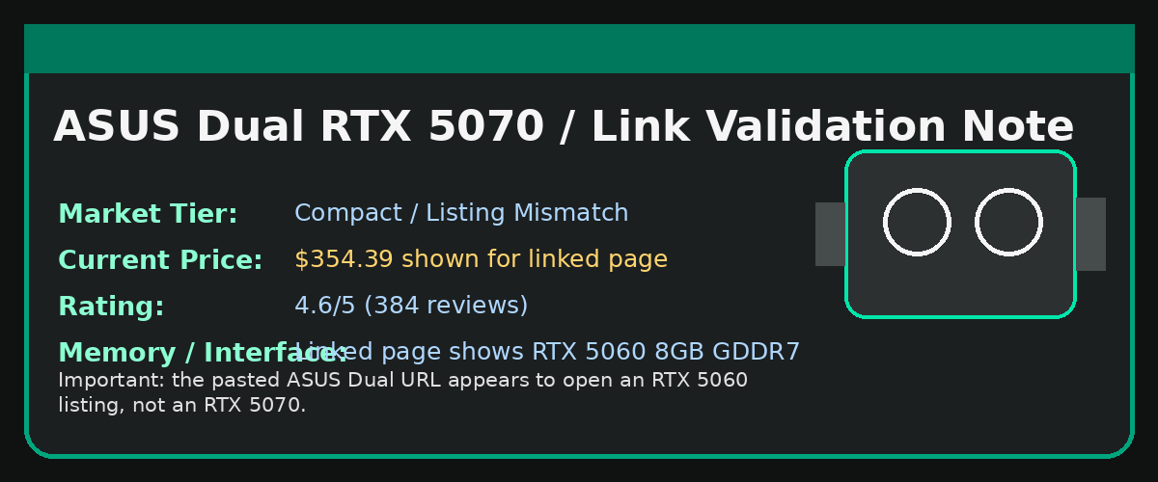
Market Tier | Compact / Listing Mismatch
Current / Listed Price | $354.39 shown for linked page
Rating Score | 4.6/5 (384 reviews)
Memory / Bus | Linked page shows RTX 5060 8GB GDDR7
Clock / Outputs / Cooling | Not verified as RTX 5070 from provided link; HDMI 2.1b + DisplayPort 2.1b on linked RTX 5060 listing; Dual Axial-tech fan design
Best Buyer Type | Only use this entry after verifying the correct RTX 5070 product URL.

Expanded Market Explanation
This entry needs a clear correction. The provided ASUS Dual URL appears to point to an ASUS Dual GeForce RTX 5060 8GB GDDR7 OC Edition listing, not an RTX 5070. Because of that, the low price shown for this link should not be compared directly with the RTX 5070 models above. If the assignment requires only RTX 5070 cards, this item should be replaced with a verified ASUS Dual RTX 5070 link or removed from the final comparison.

Strengths
- Compact dual-fan ASUS design is suitable for smaller cases.
- ASUS Dual cards are usually practical for simple, clean builds.
- The linked listing has a strong rating, but it is for the shown RTX 5060 page.

Weaknesses / Buying Cautions
- Provided URL does not verify as RTX 5070.
- Price is not comparable to RTX 5070 pricing.
- Should not be used for RTX 5070 market ranking unless the link is corrected.
Amazon Product Link: Open Product Page

MSI RTX 5070 Shadow
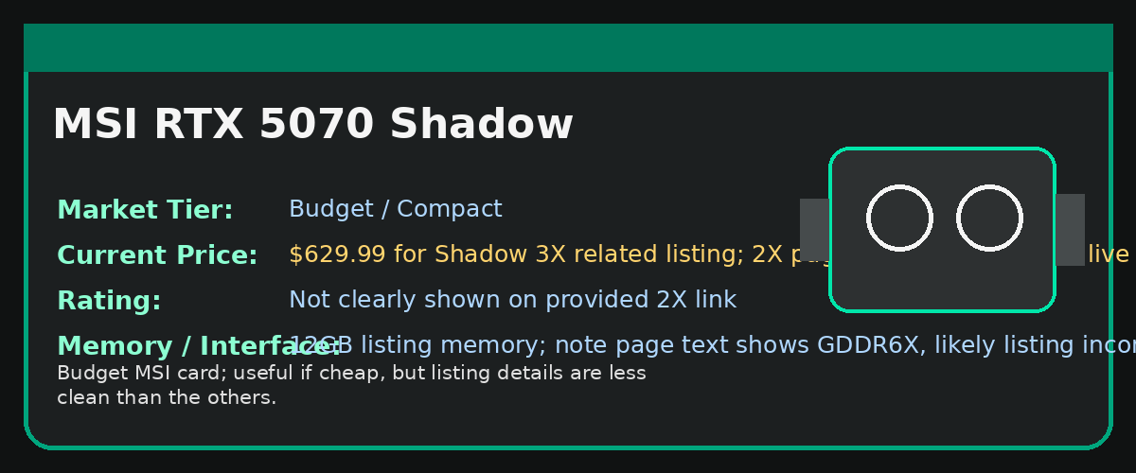
Market Tier | Budget / Compact
Current / Listed Price | $629.99 for Shadow 3X related listing; 2X page requires sign-in for live price
Rating Score | Not clearly shown on provided 2X link
Memory / Bus | 12GB listing memory; note page text shows GDDR6X, likely listing inconsistency
Clock / Outputs / Cooling | Approx. 2.54 GHz / 2557 MHz related listing; DisplayPort + HDMI; 2X or 3X depending on exact Shadow listing
Best Buyer Type | Buyers who only need basic RTX 5070 performance and prioritize the lowest MSI price.

Expanded Market Explanation
The MSI Shadow is positioned as a lower-cost RTX 5070 option. The provided Shadow 2X link shows RTX 5070, 12GB memory, DisplayPort/HDMI, and a compact two-fan style listing, but the page also shows inconsistent memory text compared with standard RTX 5070 GDDR7 expectations. A related MSI Shadow 3X listing shows 12GB GDDR7, 192-bit, 2557 MHz, DisplayPort 2.1a, HDMI 2.1b, and a $629.99 price. This means the Shadow should be treated as a budget MSI option, but the exact listing should be double-checked before purchase.

Strengths
- Potentially one of the cheaper MSI RTX 5070 options.
- Good choice if the price is clearly below Gaming Trio and Ventus.
- Compact options can help with smaller builds.

Weaknesses / Buying Cautions
- Less premium cooling and aesthetics.
- Listing information appears less consistent than other models.
- Should be verified carefully before using in final purchasing decision.
Amazon Product Link: Open Product Page

Final Market Recommendations
Category | Recommended Card | Reason
Best Overall GPU | ASUS Prime RTX 5070 OC | Strong balance of cooling, reliability, rating, and price.
Best Enthusiast GPU | MSI RTX 5070 Gaming Trio | Best premium cooler and quieter long-session performance.
Best Value GPU | Gigabyte RTX 5070 Windforce OC | Good triple-fan RTX 5070 performance at a lower price.
Best RGB Mid-range GPU | PNY RTX 5070 OC Epic-X RGB | Good styling, strong boost clock, and reasonable price.
Best White Build GPU | Gigabyte RTX 5070 Aero OC | Best choice for white-themed aesthetic gaming PCs.
Needs Link Verification | ASUS Dual Entry | Provided link appears to show RTX 5060, not RTX 5070.

Overall Conclusion: For most buyers, the Gigabyte Windforce OC gives the best value, while the ASUS Prime RTX 5070 OC is the safer overall pick. The MSI Gaming Trio is best when silence and cooling matter more than price. The Gigabyte Aero OC should mainly be chosen for white-themed builds. The ASUS Dual entry should be corrected with a verified RTX 5070 URL before being used in a final buying decision.

Source Notes
- Original pasted report content: User-provided pasted markdown content
- ASUS Prime RTX 5070 OC: Source Link
- Gigabyte RTX 5070 Windforce OC: Source Link
- PNY RTX 5070 OC Epic-X RGB: Source Link
- MSI RTX 5070 Gaming Trio: Source Link
- MSI RTX 5070 Ventus: Source Link
- Gigabyte RTX 5070 Aero OC: Source Link
- ASUS Dual provided URL: Source Link
- MSI RTX 5070 Shadow provided URL: Source Link

